Student Name : Prajalkumar Ramjiyani

Student Id : 12045947

Course name : Master of IT

Course Code : CC54

Tutor: Watagodakumbura, Chandana Dharma

Outputs :

Test Result 1:

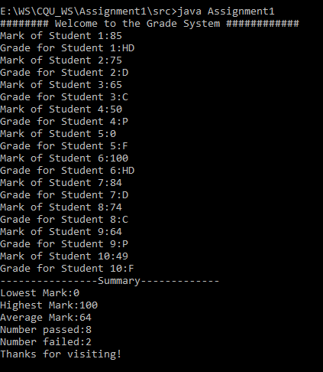

Test Result 2:

